MINI PROJECT LOG BOOK

GROUP MEMBERS

1. JIMIT NAVINBHAI ANDARPA

2. NEHA DINESH SHIRSAT

Supervisor

Prof. SMITA PATIL

Guid

Prof.SNEHA YADAV

**STUDENT INFORMATION**

Project Title: **COURIER MANEGEMENT SYSTEM.**

|  |  |  |
| --- | --- | --- |
|  | **Student 1** | **Student 2** |
| **Name** | Jimit NavinBhai Andarpa | Neha Dinesh Shirsat |
| **Enrollment No** | 225480 | 227389 |
| **Semester** | Semester 2 | Semester 2 |
| **Contact No.** | 9579033206 | 9022745317 |
| **E-mail** | jimitandy26@gmail.com | nehashirsat98@gmail.com |

**INSTRUCTIONS TO STUDENTS:**

1. The logbook must be submitted to the Guide for verification and evaluation of project activities at least once in a week.
2. Log book duly signed by guide must be submitted with project report for evaluation at the end of semester .

# DECLARATION

I declare that this project represents my ideas in my own words and wherever others' ideas or words have been included, I have adequately cited and referenced the original sources. I also declare that I have adhered to all principles of academic honesty and integrity and have not misrepresented or fabricated or falsified any idea/data/fact/source in my project work. I understand that any violation of the above will be cause for disciplinary action by the Institute.

Yours Faithfully

1.Jimit Navinbhai Andarpa.

2.Neha Dinesh Shirsat.

(Signature of Students)

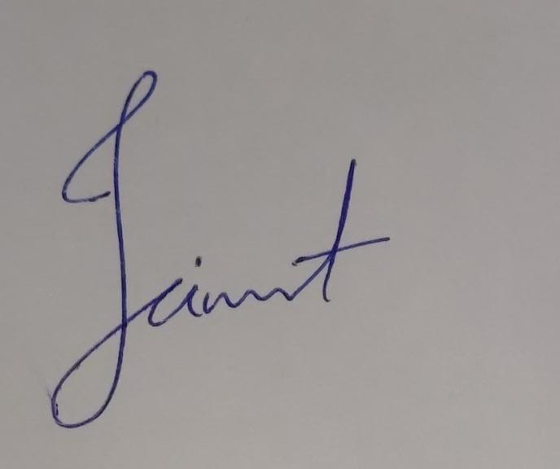

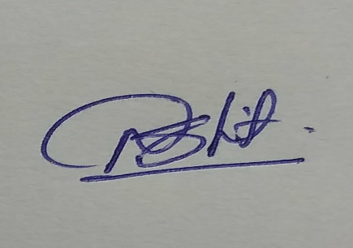

# Letter of Acceptance

I undersigned ,Prof . **SMITA PATIL** willing to Guide The Project titled

**COURIER MANEGEMENT SYSTEM.**

for the mini project- Semester I /III respectively for the academic year 2021-22. The names of the students are:

1.**JIMIT NAVINBHAI ANDARPA**

2.**NEHA DINESH SHIRSAT**

**( Project Guide)**  **SNEHA YADAV**

**SCHEDULE FOR MINI PROJECT**

|  |  |  |  |  |
| --- | --- | --- | --- | --- |
| **Date** | **Time** | **Session** | **Contents** | **Remark** |
| 13/7/2022 | 11.00 am to 12.00pm | 1 | Introduction of the project, problem definition, objective and scope of the project | DONE |
| 14/7/2022 | 11.00 am to 12.00pm | 2 | System study-existing system, proposed system,, Use cases | DONE |
| 15/7/2022 | 11.00 am to 12.00pm | 3 | Software and hardware requirements specifications, Gantt chart, DFD diagram, ER diagram, flowchart, module design and organization | DONE |
| 16/7/2022 | 11.00 am to 12.00pm | 4 | Manual and automation testing test cases | DONE |
| 17/7/2022 | 11.00 am to 12.00pm | 5 | Explanation of key functions, Project implementation, Front end and output screenshots | DONE |
| 18/7/2022 | 11.00 am to 12.00pm |  | Project conclusion and further enhancements |  |

**PROGRESS/ATTENDANCE REPORT**

|  |  |
| --- | --- |
| Title of the Project: **COURIER MANEGEMENT SYSTEM.** | |
| Group No. | Name of Student 1: **Jimit Navinbhai Andarpa.** |
| Name of Student 2: **Neha Dinesh Shirsat.** |
|  |
| Name of the Supervisor: | |

|  |  |  |  |  |  |  |
| --- | --- | --- | --- | --- | --- | --- |
| Sr. No | Date | Time | Attendance | | | Progress/Suggestion |
|  |  |  | 1 | 2 | 3 |  |
| 1 |  |  |  |  |  |  |
| 2 |  |  |  |  |  |  |
| 3 |  |  |  |  |  |  |
| 4 |  |  |  |  |  |  |
| 5 |  |  |  |  |  |  |

|  |  |  |  |  |  |  |  |  |
| --- | --- | --- | --- | --- | --- | --- | --- | --- |
| 6 |  |  |  |  | Presentation1 |  |  |  |

Sign of the Supervisor

# 